# Milestone 3

## Development

Github Link: <https://github.com/yjp20/160-group-18>

### Tasks

* **Evaluate:** Display information about a specific coffee (taste profile, cost, certifications, roaster, origin, etc.) so that the user can make relevant evaluations of the various coffees that they might like. Support supply traceability down to which farms certain coffees use.

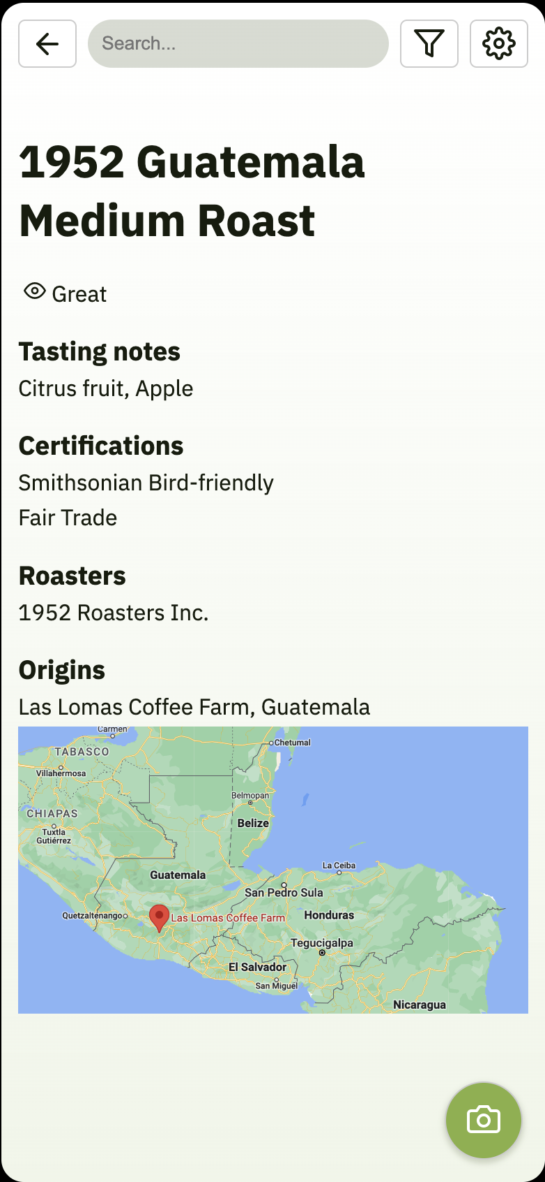

* **Discover:** Enable users to find new coffee shops with coffee that they might like through “Nearby Stores” and “Search”. Use a simple star system for coffee shops.  
  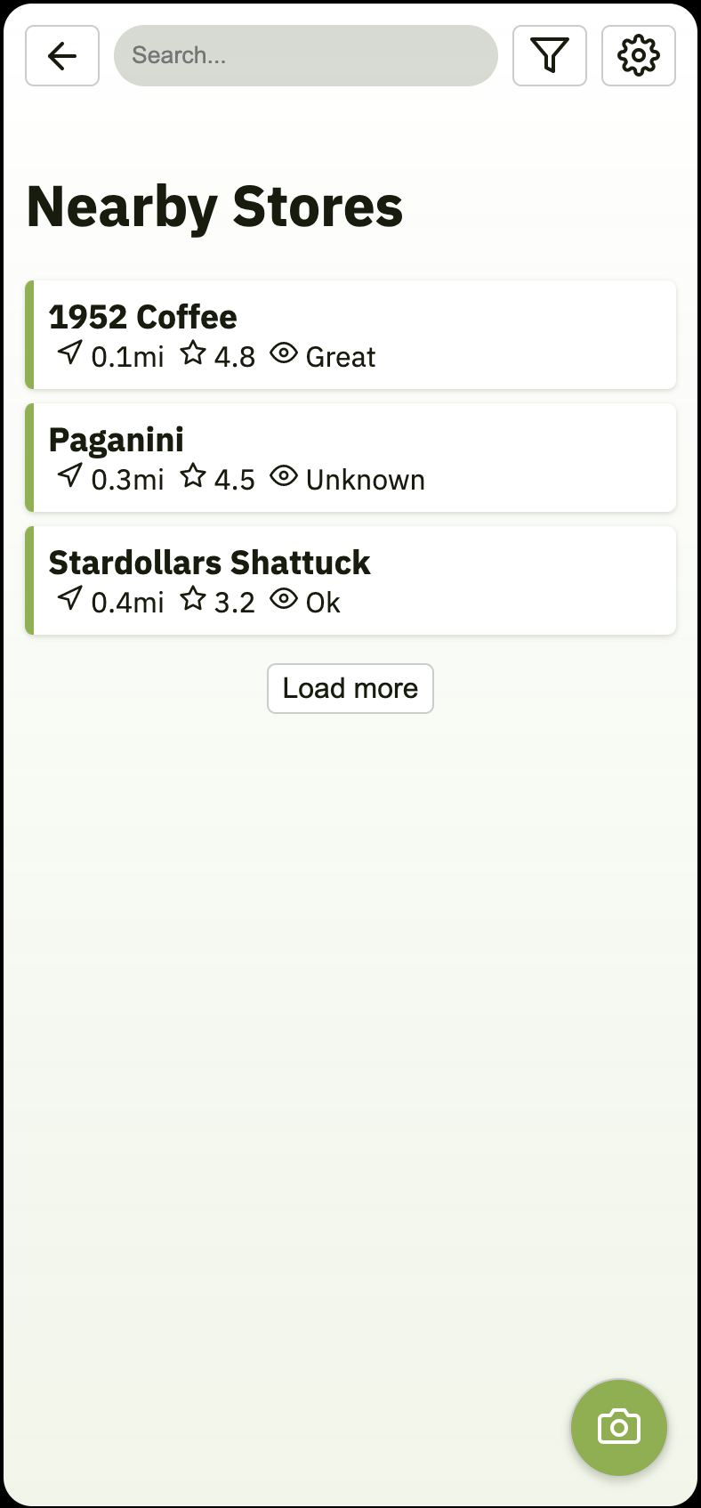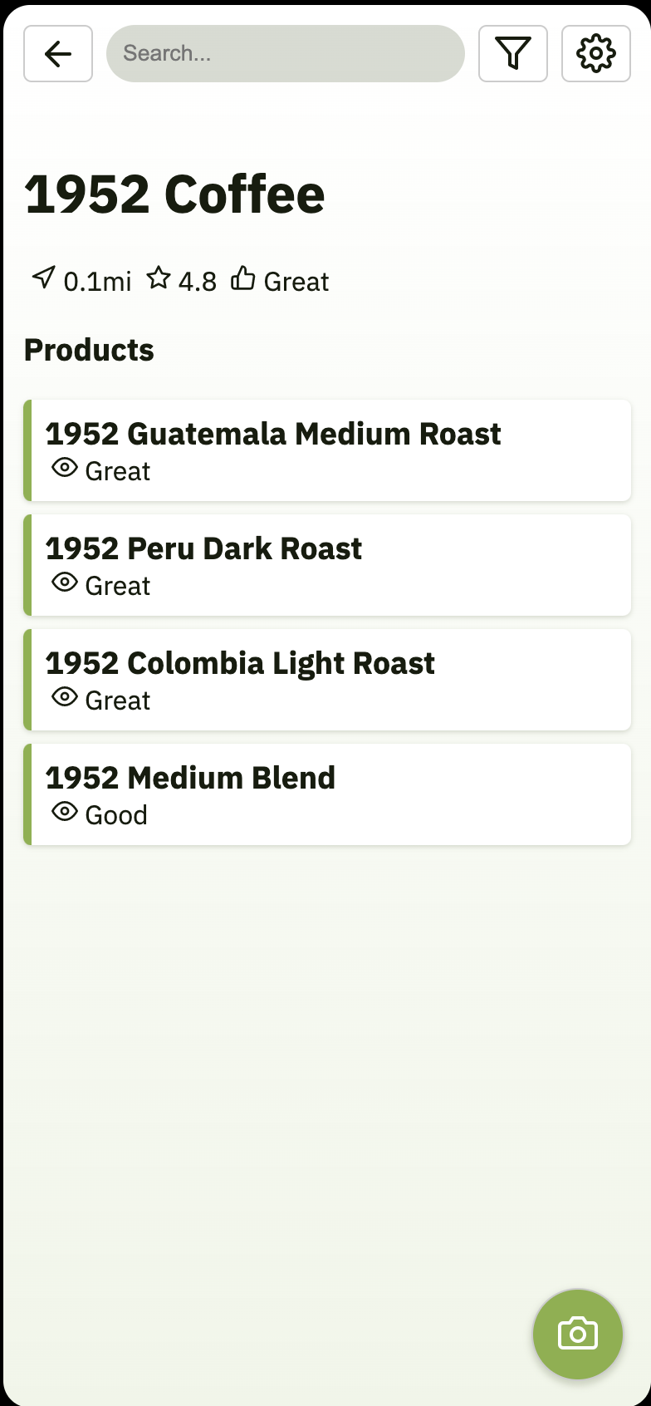
* **Query:** Find relevant coffee easily though a camera-based barcode scanner and the search system, so they can browse in-person and access information in real time.  
  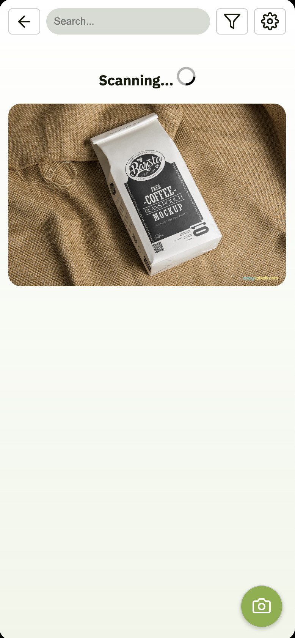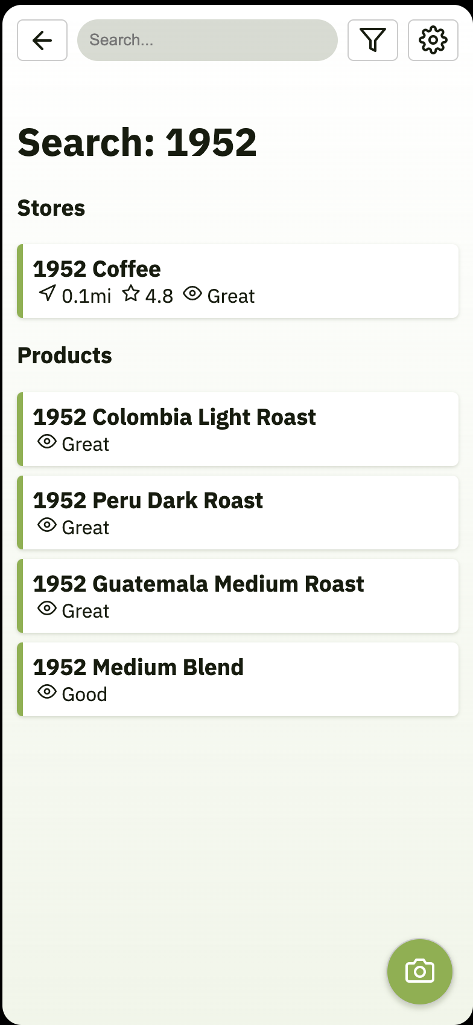

## 

## User Evaluation

### Evaluation Study Design

In the evaluation study, our main goal is to test the effectiveness of the three major functions (evaluate, discover, query) of our application.

After giving the participants a brief introduction about the study’s background and its goal, we’ll give them a bag of coffee beans with its product name “1952 Guatemala medium roast” marked on its package. Then we’ll ask the user to provide more detailed information about this coffee bean with the following questions:

1. Can you tell me something more detailed about this coffee bean (e.g., its roaster, farm of origin, certifications, tasting notes, etc.)?

2. Are there any stores nearby that uses this kind of beans for their coffee?

3. (Following q2) Can you name one other product this store has?

4. Based on the information you just saw, were you able to tell if the coffee bean is eco-friendly?

The participants will answer the above questions with the help of our prototype. Some functions of the prototype (e.g., scanning the product) will be tested using the “Wizard of Oz” technique. We’ll take note on how the participants look up the information, and ask them questions on what prompted them to do so.

After the study, we’ll ask the participants how they felt about the experience using the prototype and was there any confusion that should be cleared.

### Synthesis

Both participants of the study were able to find the information we asked for during the study using the search bar & scan function. The iteration of pages was also making sense to them as they had no trouble moving between pages.

The only issue that was identified is that both participants seemed confused when they were asked about whether the coffee bean is eco-friendly or not. According to their feedback, instead of showing them the production process, it would be easier for users to tell whether the beans are eco-friendly or not if we can add a “eco-friendly certified” mark on the beans’ product detail page.